SMART SOLUTION FOR RAILWAYS

TEAM ID:PNT2022TMID35794

SPRINT-2: DASHBOARD:

MIT APP INVENTOR:

BACK-END SCREENSHOTS:

SCREEN-3:(WELCOME)
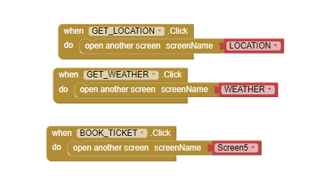

SCREEN-4:(FORGRT PASSWORD)
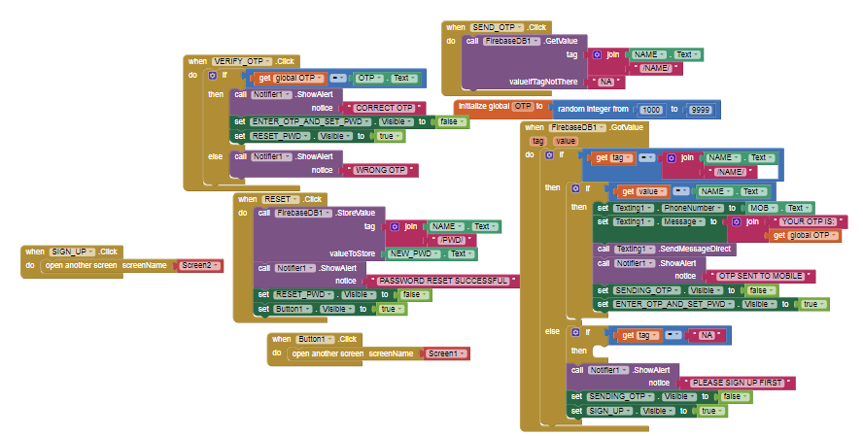

FRONT-END SCREENSHOTS:

SCREEN-3:
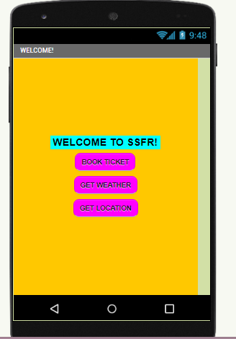

SCREEN-4:

: